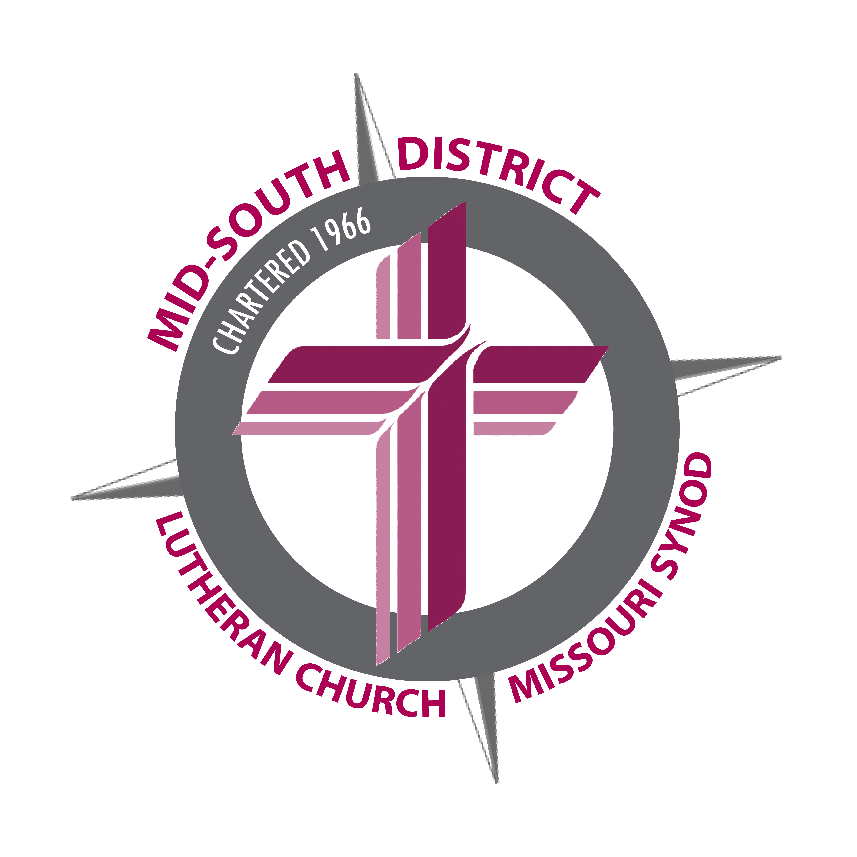

Please respond by January 3, 2017, if possible

Treasurer’s Workshop
Registration Form

Name:_____________________________________________________________________

Church:____________________________________________________________________
(Name) (City) (State)

Please circle the one you will attend:

January 7, 2017 – 9:00 a.m. – 11:30 a.m.
11:30 a.m. – 12:00 p.m. – Lunch (provided)
12:00 p.m. – 2:30 p.m. Concordia Plans Services
Grace Lutheran Church
9076 Middlebrook Pike
Knoxville, TN

January 14, 2017 – 9:00 a.m. – 11:30 a.m.
11:30 a.m. – 12:00 p.m. – Lunch (provided)
12:00 p.m. – 2:30 p.m. Concordia Plans Services
Grace Lutheran Church
5124 Hillcrest Avenue
Little Rock, AR

January 21, 2017 – 9:00 a.m. – 11:30 a.m.
11:30 a.m. – 12:00 p.m. – Lunch (provided)
12:00 p.m. – 2:30 p.m. Concordia Plans Services
Mid-South District Office
1675 Wynne Road
Cordova, TN

January 28, 2017 – 9:00 a.m. – 11:30 a.m.
11:30 a.m. – 12:00 p.m. – Lunch (provided)
12:00 p.m. – 2:30 p.m. Concordia Plans Services
Bethel Lutheran Church
5400 Euper Lane
Fort Smith, AR

February 4, 2017 – 9:00 a.m. – 11:30 a.m.
11:30 a.m. – 12:00 p.m. – Lunch (provided)
12:00 p.m. – 2:30 p.m. Concordia Plans Services Our Savior Lutheran Church
5110 Franklin Road
Nashville, TN

Suggested Questions and Discussion Items:

__________________________________________________________________________

__________________________________________________________________________
Return to: Mid-South District LCMS
1675 Wynne Road
Cordova, TN 38016

