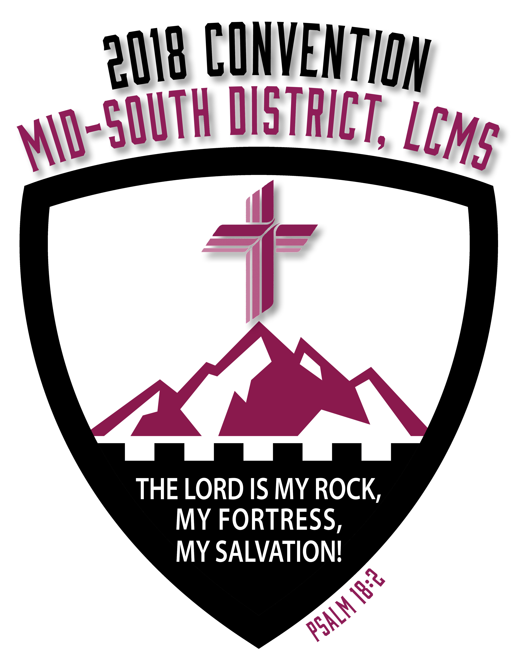
Overture A For Mid-South District Convention Consideration

SUBJECT: To (Desired Action – Consideration, etc.)

WHEREAS, _____________________; and

WHEREAS, _____________________; and

WHEREAS, _____________________; therefore be it

RESOLVED, That _________________; and be it further

RESOLVED, That _________________; and be it further

RESOLVED, That _________________; and be it finally

RESOLVED, That _________________. (i.e., the Mid-South District submit this memorial to the next convention of the Synod.)

Respectfully submitted,

Name of Congregation
City/State

______________________________________
Signed by Congregational President

______________________________________
Name of Congregational President (Printed)

______________________________________
Signed by Congregational Secretary

______________________________________
Name of Congregational Secretary (Printed)

