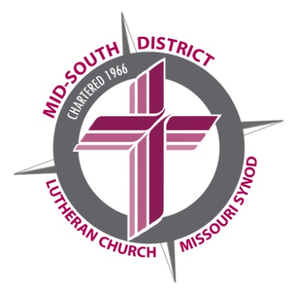

1675 Wynne Road
Cordova, TN 38016
Phone: 901-373-1343
Fax: 901-373-4826
www.mid-southlcms.com

The Mid-South District
of The Lutheran Church—Missouri Synod

February 21, 2022

Fellow Servants of our Lord and Savior Jesus Christ!

We are sending this letter to prospective students or those from our Mid-South District who are already in the process of preparing for full-time church service.
We continue to thank God for the gifts to His Church for the purpose of proclaiming and teaching the Gospel! We rejoice that our District is blessed to have financial resources to share with its students to help with educational and living expenses while attending one of the Seminaries or a Concordia University System institution.

The District’s financial assistance comes from three sources: generous LWML grants, endowment funds provided by God’s faithful stewards, and dollars in the District budget made possible from congregational mission gifts. As a result, Mid-South District grants have been among the most generous in Synod, all made possible by your fellow brothers and sisters who are committed to the formation of gifted people to serve in our congregations and schools.

The District Committee that awards these grants follows established guidelines. Among them is the expectation that students who apply are members in good standing of Mid-South District congregations and are enrolled in a Seminary or a University System institution to prepare for full-time service to the Church as a rostered worker. Rostered positions are Pastors, Teachers, Directors of Christian Education, Directors of Christian Outreach, Deaconesses, Parish Assistant, Director of Parish Music and Director of Family Life. This practice fulfills the wishes of our generous benefactors.

We ask that you initiate your financial aid assistance request by informing our office that you will be or are currently a student enrolled at a synodical school. If you do not do this, we have no way of knowing that you will be or are now a student seeking District assistance. You may inform us in one of three ways:

- Email your request to be considered along with information about where you will be attending school.
Email to: jtyler@mid-southlcms.com

2. Write us a letter at: Mid-South District of The Lutheran
Church--Missouri Synod
1675 Wynne Road
Cordova, TN 38016

3. Call us at: 1-866-373-1343 (toll free)

Rev. Dr. Roger Paavola
President
rpaavola@mid-southlcms.com

Rev. William Zwick
Executive Director for
Mission and Ministry
wzwick@mid-southlcms.com

Angela Fowler
Executive Director for
Business and Finance
afowler@mid-southlcms.com

Paul Reaves
LCEF Vice President and
Executive Director for
Development
paulreaves@aol.com

Allen Piepenbrink
Executive Director for
Schools and Early Childhood
apiepenbrink@mid-southlcms.com

Next, please complete the necessary forms (enclosed) in a timely manner, and send the District Financial Aid Application to the appropriate Seminary or CUS institution. Return the appropriate District forms to our office. Our guidelines ask that you go through the above two steps every year you are in need of financial assistance.

Once again, we cannot release dollars for student aid until the applicant has personally informed us of the desire to apply for student financial assistance, and completed the forms to be submitted to the school of choice. Only then will the funds be released to the Concordia University System Institution or one of the Seminaries of the Synod. The deadline for notification, completion of forms, and returning them to our office is June 15.

If you have further questions, please call 1-866-373-1343 (toll free) immediately and speak with Mrs. Julie Tyler.

Thanks for your response and help so that we can be good stewards of God’s resources. Our District rejoices that we have students attending one of our Synodical Schools in preparation for service in the Church so more people will hear the Good News of God’s forgiving and accepting love through Jesus.

We look forward to hearing from you as often as possible. You are in our prayers!

In His Service,

Angela Fowler
On behalf of the District Student Financial Assistance Committee

AF/jt

Enclosures: District Financial Aid Application
Pastor’s Evaluation of Applicant Form
Agreement of Payment
Scholarship Guidelines

