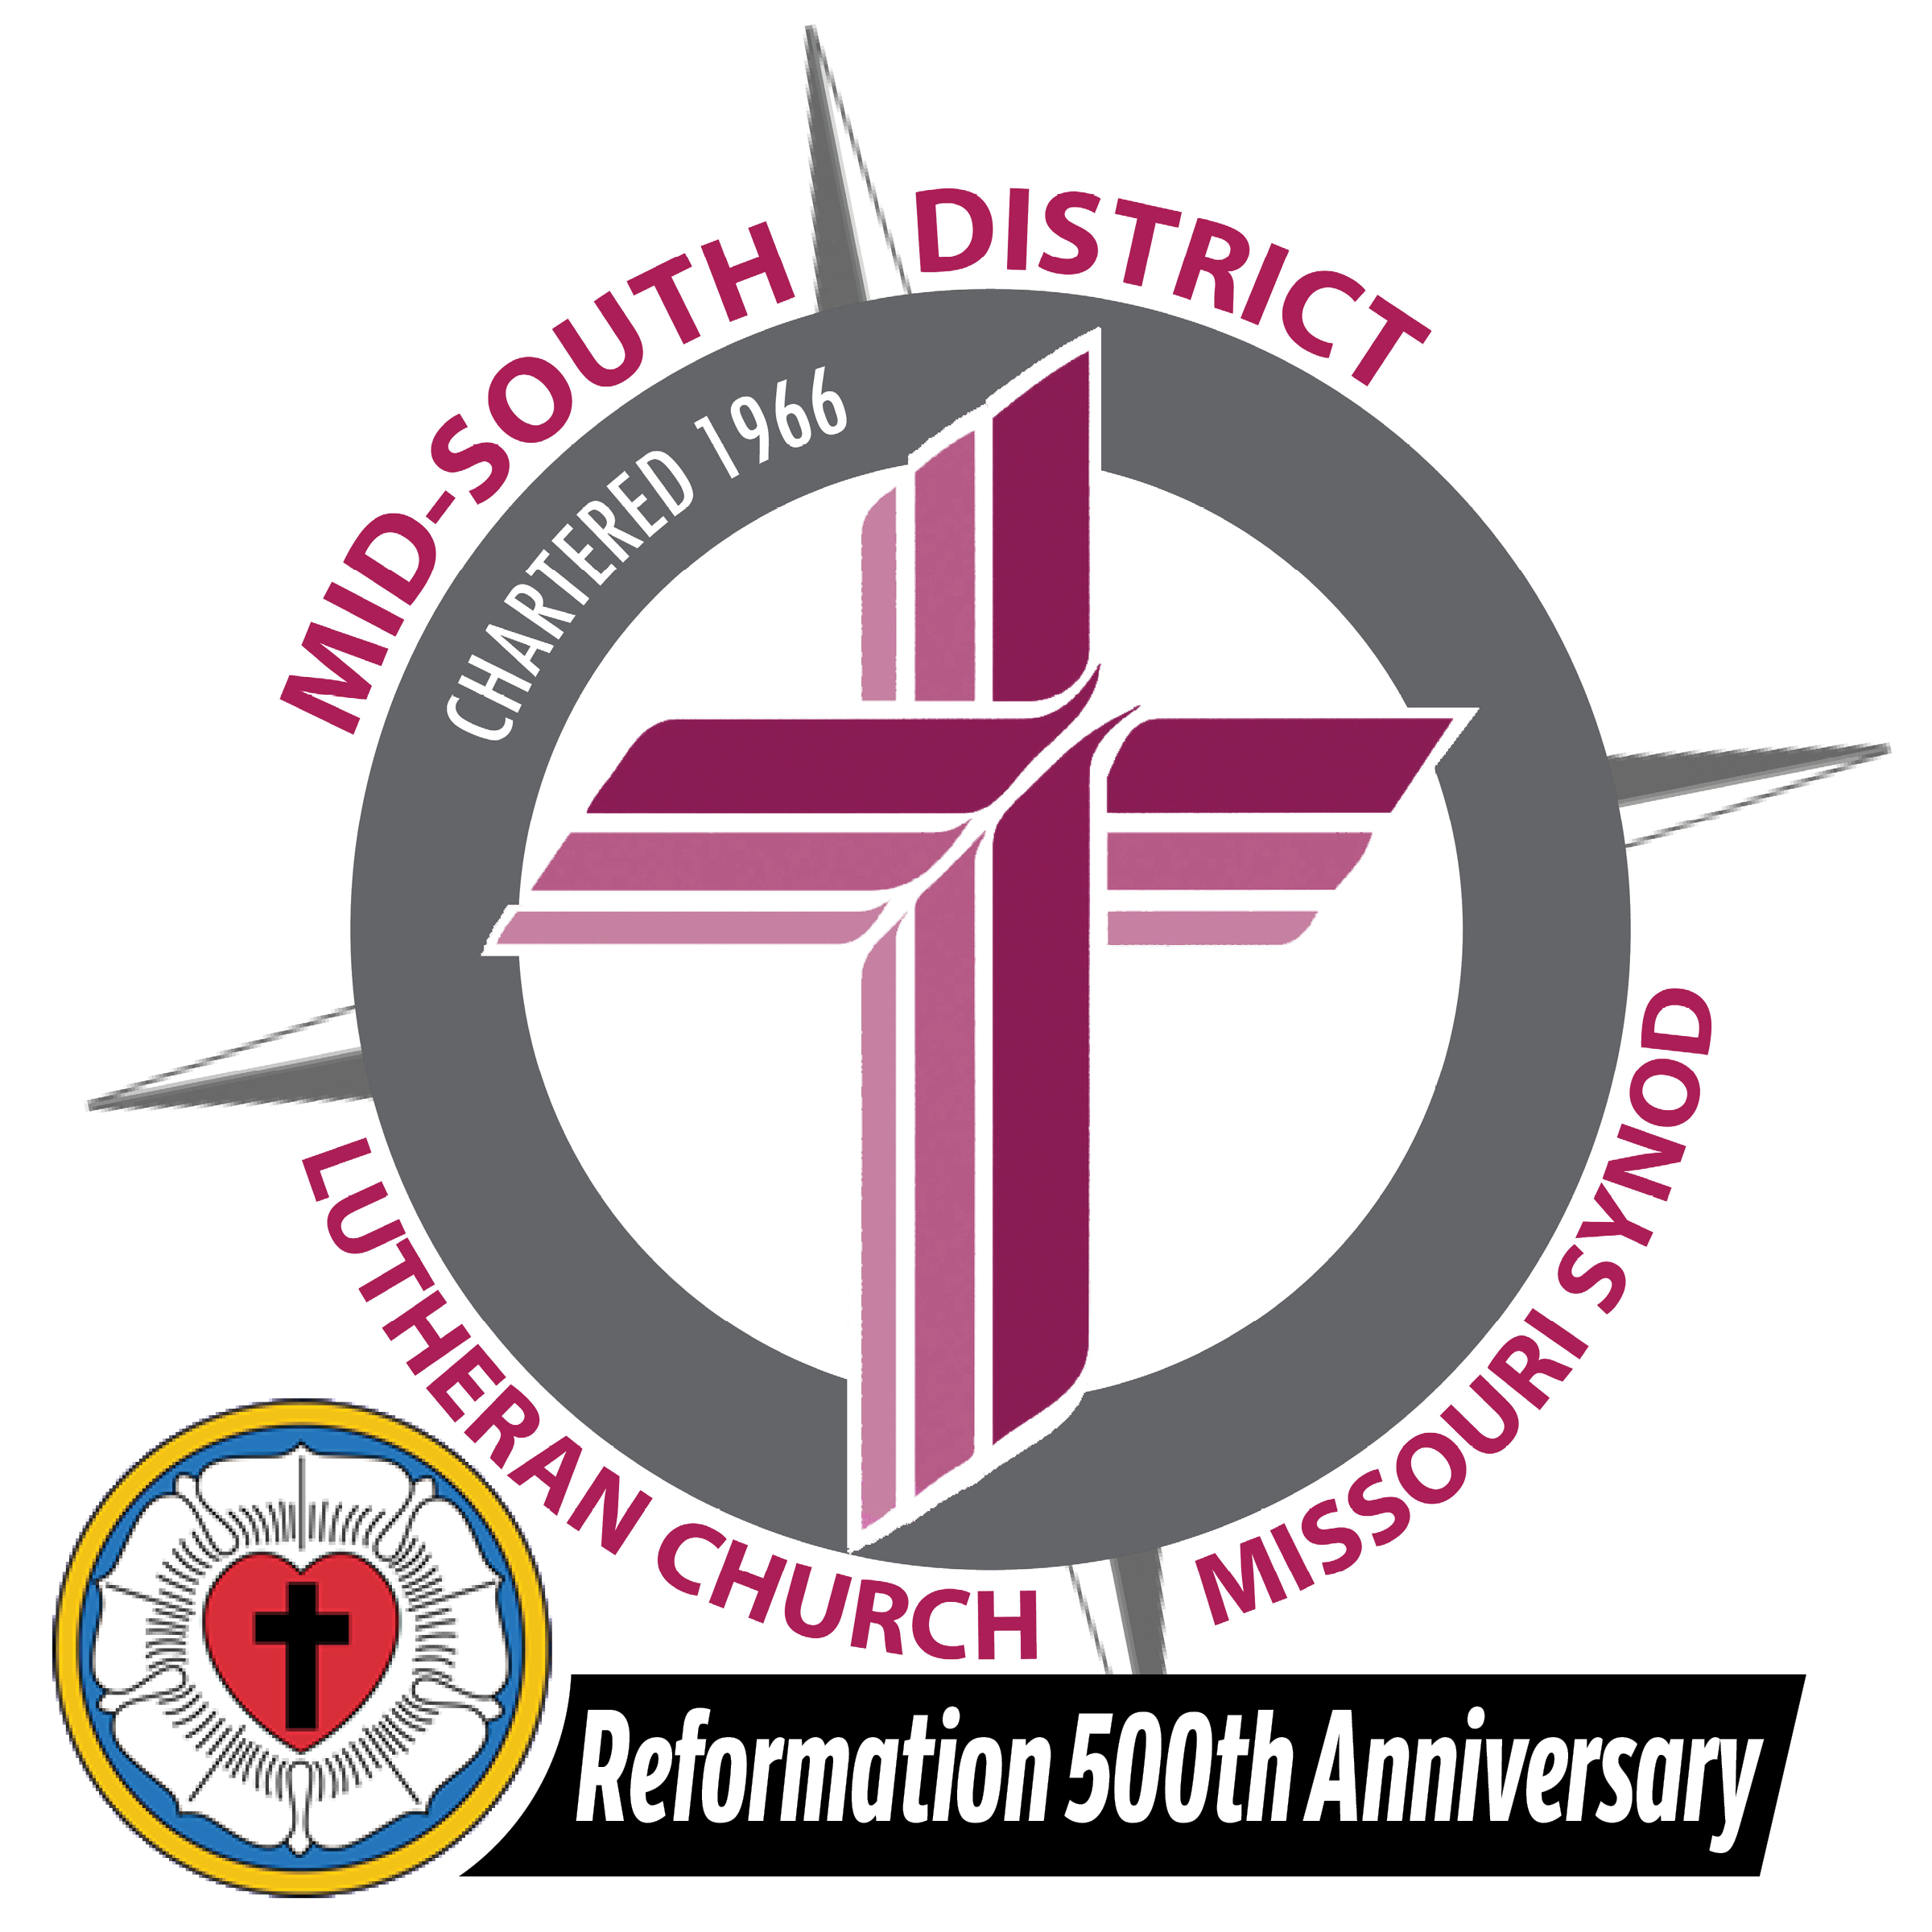

Please respond by December 31, 2020, if possible

2021 Treasurer’s Workshop Registration Form

Name:_____________________________________________________________________

Church:____________________________________________________________________
(Name) (City) (State)

Please circle the one you will attend:

January 2, 2021 – 9:00 a.m. – 11:00 a.m. Treasurer’s Manual – Volume 1
11:00 a.m. – 11:30 a.m. Lunch (provided)
11:30 a.m. – 1:00 p.m. CPS Compensation Decision Tool/
Grace Lutheran Church QuickBooks
9076 Middlebrook Pike
Knoxville, TN

January 9, 2021 – 9:00 a.m. – 11:00 a.m. Treasurer’s Manual – Volume 1
11:00 a.m. – 11:30 a.m. Lunch (provided)
11:30 a.m. – 1:00 p.m. CPS Compensation Decision Tool/
Grace Lutheran Church QuickBooks
5124 Hillcrest Avenue
Little Rock, AR

January 16, 2021 – 9:00 a.m. – 11:00 a.m. Treasurer’s Manual – Volume 1
11:00 a.m. – 11:30 a.m. Lunch (provided)
11:30 a.m. – 1:00 p.m. CPS Compensation Decision Tool/
St. John Lutheran Church QuickBooks
500 N. Cumberland Avenue
Russellville, AR

January 23, 2021 – 9:00 a.m. – 11:00 a.m. Treasurer’s Manual – Volume 1
11:00 a.m. – 11:30 a.m. Lunch (provided)
11:30 a.m. – 1:00 p.m. CPS Compensation Decision Tool/
Mid-South District Office QuickBooks
1675 Wynne Road
Cordova, TN

January 30, 2021 – 9:00 a.m. – 11:00 a.m. Treasurer’s Manual – Volume 1
11:00 a.m. – 11:30 a.m. Lunch (provided)
11:30 a.m. – 1:00 p.m. CPS Compensation Decision Tool/
Our Savior Lutheran Church QuickBooks
5110 Franklin Road
Nashville, TN

Suggested Questions and Discussion Items:

__________________________________________________________________________

__________________________________________________________________________
Return to: Mid-South District LCMS
1675 Wynne Road
Cordova, TN 38016

